**Machine Learning Project 6**

Ailiyasi Ainiwaer (Elyas)

Xiaoli Qiu

We used Matlab built-in convolutional neural network function and MNSIT handwritten digits data from Lecun et al. (<http://yann.lecun.com/exdb/mnist/>) to train and test our network. We also tested our network with Elyas’s and Xiaoli’s handwritten digits.

1. Data

We used 60000 images to train our network, then used 10000 images for testing.

1. Network Architecture

We used a modified version of LeNet-5 as our network architecture:

Input: 28×28

Convlution1: 6, 5×5 filters (output size: 24×24×6) with a stride of 1 plus 6 bias so 1st layer total number of learning parameters = 5×5×6+6=156

Relu activation

Max pooling1: 2×2 filters with a stride of 2 (output size: 12×12×6)

Convolution2: 16, 5×5 filters(output size: 8×8×16) with a stride of 1 plus 16 bias so 2nd layer total number of learning parameters = 5×5×6×16+16=2416

Relu Activation

Max pooling2: 2×2 filters with a stride of 2 (output size: 4×4×16)

Flatten layer: an input for the fully connected layer: 4×4×16=256

Fully connected layer with 10 output: total number learning parameters = 256×10 +10= 2570

Softmax and classification

1. Training time

In optimization, we used stochastic gradient descent with momentum , multiple cpu cores used with Matlabs parallel computing function. So, Training time = 86.1249sec (Fig.1 , output from Matlab). We also checked convergence of algorithm by plotting loss and accuracy versus iteration (Fig.2, Matlab built -in plotting feature).

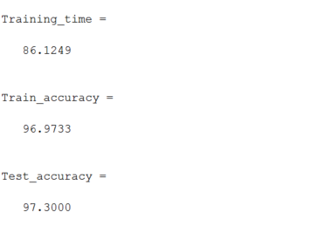

Figure 1. Screen shot of training time, training accuracy, and test acuracy.

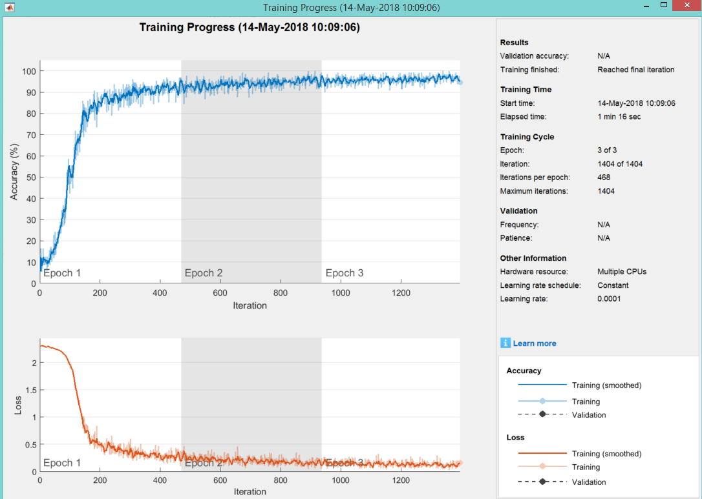

Figure 2. Screenshot of training progress (Matlab built-in feature)

1. We used the trained network to calculate prediction then compare with labels, then calculate accuracy using equation,

accuracy = (number of corrected labeled samples/ total number of samples) *100

so, Training accuracy = 96.9733% and Testing accuracy = 97.3000%.

To visual check performance of network recognition on the test set, we plotted 10 correctly labelled images(Fig.3) and 10 mislabeled images(Fig.4).

1. Finally, we tested our trained network with Elyas’s (Fig.5) and Xiaoli’s (Fig.6) handwritten digit samples. We used various Matlab built-in image processing functions to produce input images similar to LeCun’s dataset.

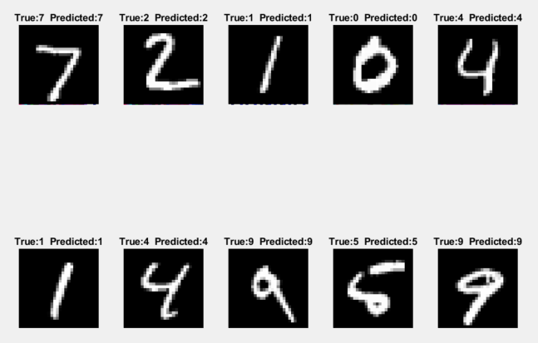

Figure 3. 10 correctly labeled images from test data

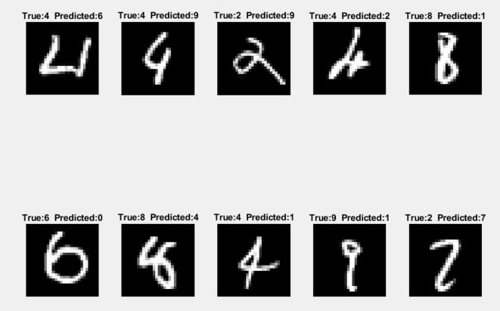

Figure 4. 10 incorrectly labeled images from test data

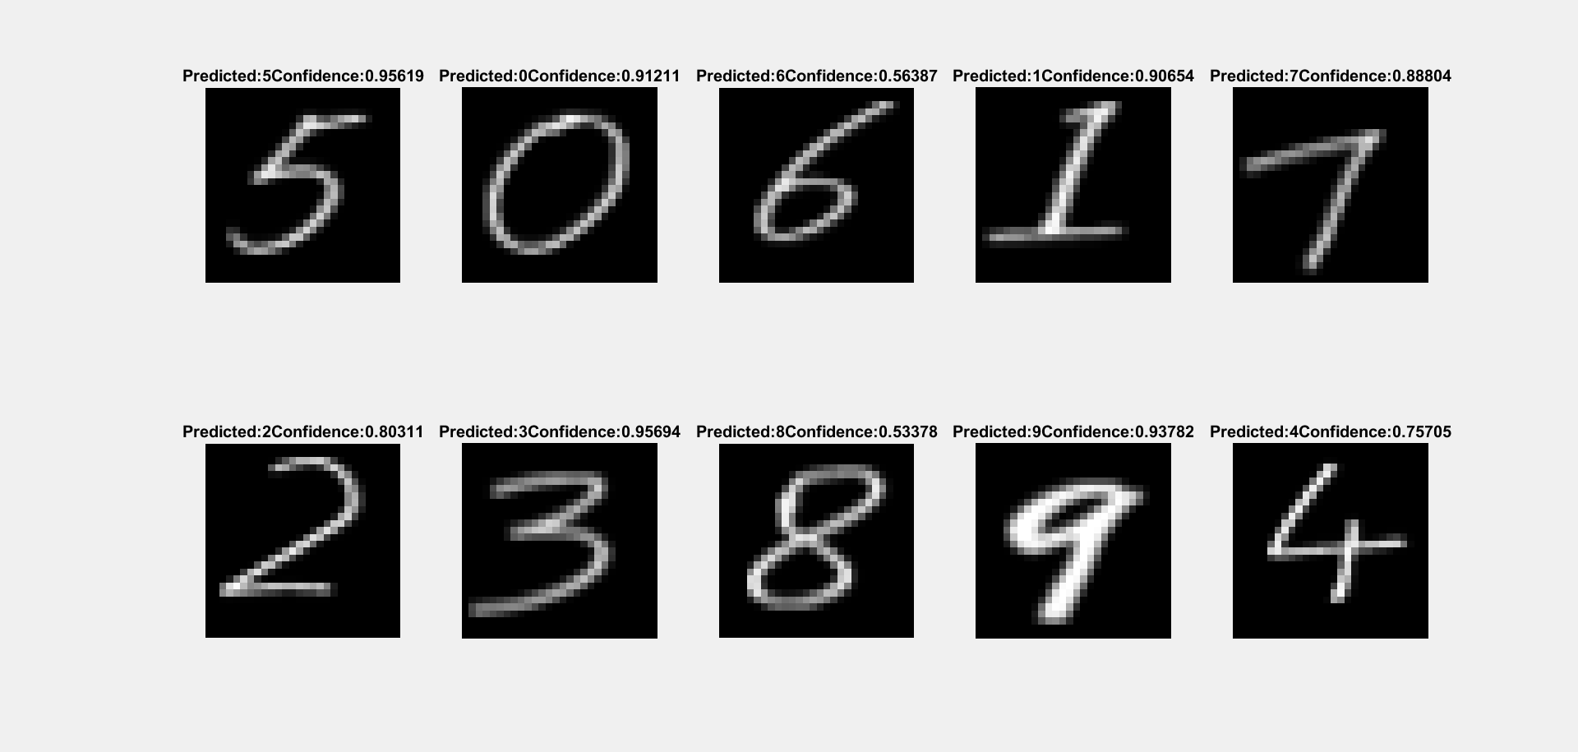

Figure 5. Cropped and predicted images (Elyas)

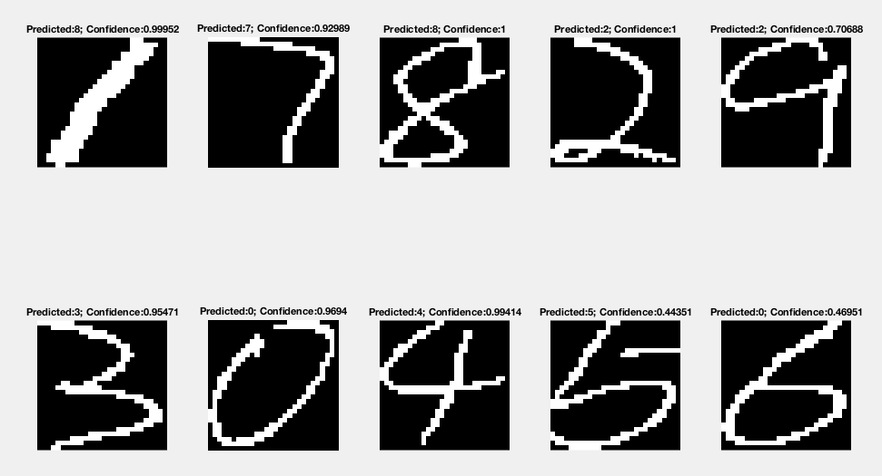

Figure 6. Cropped and predicted images (Xiaoli)